The Easton Garden Club’s Annual Wreath Sale
Holiday Poinsettias Wreaths White Pine Roping
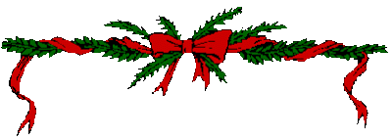
Prepaid orders only – accepted until Friday, November 17th
Order now and pick-up on Tuesday, November 28th
At the Easton Library Community Room from 1:00-5:15pm
Keep this half for your reminder
-------------------------------------------Detach here and submit------------------------------------------
Wreaths
 | Small 12”  $11 ea. | Medium 16”  $15 ea. | Large 24”  $27 ea. | Barn 36”  $50 ea. | Wreaths  $ Total
Quantity
Poinsettia
 | Small (Single)  $11 ea. | Medium (Double)  $17 ea. | Large (Triple)  $36 ea. | Poinsettia  $ Total
Red
White
Pink
Roping
 | $32 ea. | Roping $ Total
25 yards White Pine

$ Order Total:___________
Mail order form with check payable to:
Easton Garden Club, P.O. Box 101, Easton, CT 06612
Please print clearly
Name:_________________________________________________________________________________
Address:________________________________________Town:______________________Zip_________
Phone:___________________________Email:________________________________________________
Easton Garden Club is a 501(C)(3) Charitable Organization
Proceeds from this fundraiser benefit community projects, programs and activities

